Nehemiah 1

Introduction
I. Nehemiah was a great leader
A. At the core of his leadership was a heart fully abandoned to God
Zeal for the Lord = single-minded devotion
B. His life inspires and challenges lives that have 1 foot in world and 1 foot in God
= lives like the 3rd soil in the parable of the sower where there are weeds that choke out fruitfulness

II. Historical background
A. God’s calling of Abraham in 2000 BC
B. God’s calling of Moses in 1500 BC
C. God’s calling of David in 1000BC
D. The exile and return from exile in 500BC
1. The book of Nehemiah takes place after a remnant of exiled Israelites return to rebuild Jerusalem. It is a very trying and precarious time for God’s people.
2. Nehemiah is a Jew living in exile in the capital city of the Persian empire, and information about the Jews back in Israel compels him to step out and doing something for God and his people.

III. Theme for today: faithful leadership begins with us on our knees in prayer
A. There are many cultural factors that work against our prayer lives
e.g. busyness, fast-paced life, a push to achieve and be productive
B. Yet, godly leadership starts with a rich prayer life

The Passage
I. What does faithful prayer look like?
A. Faithful prayer is persistent
-v. 4: “for some days” he prayed and fasted
-v. 6: prayed “day and night”
B. Faithful prayer is rooted in an understanding of who God is (v. 5)
1. Understanding God’s unlimited power
“God of heaven, great and awesome God” (v. 5)
2. Understanding God’s personal faithfulness to his people
“who keeps his covenant of love with those who love him” (v. 5)
C. Faithful prayer is rooted in an understanding of who we are (v. 6-7)
1. Confession for the sins of Israel
2. Nehemiah identifies with Israel in their sins
D. Faithful prayer calls God to be true to his own character (v. 8-10)
1. He calls on God to be faithful to a promise God made hundreds of years ago.
2. When asking God to do something we want him to do, the only “bargaining power” we have is calling on God’s own character (mercy, faithfulness, love). There is nothing within ourselves that we can point to in order to get God to act
E. Faithful prayer gets specific (v. 11)

II. What does faithful prayer accomplish?
A. Faithful prayer moves and shapes us
1. As Nehemiah prays over a course of time, a sense of calling begins to emerge—that he is in a unique position to do something about the problem
2. When we commit to praying for something, God often shapes our own hearts and moves us to a particular course of action

B. Faithful prayer moves and shapes the world
1. God choses to answer Nehemiah’s prayer in some radical ways
2. God continues to answer prayer in radical ways
3. So, prayer is actually one of the most “productive” things we can do

Conclusion
I. How are you being called to a life of prayer during this summer season?

II. As fathers, we have the privilege and responsibility of lifting our families up in prayer regularly.

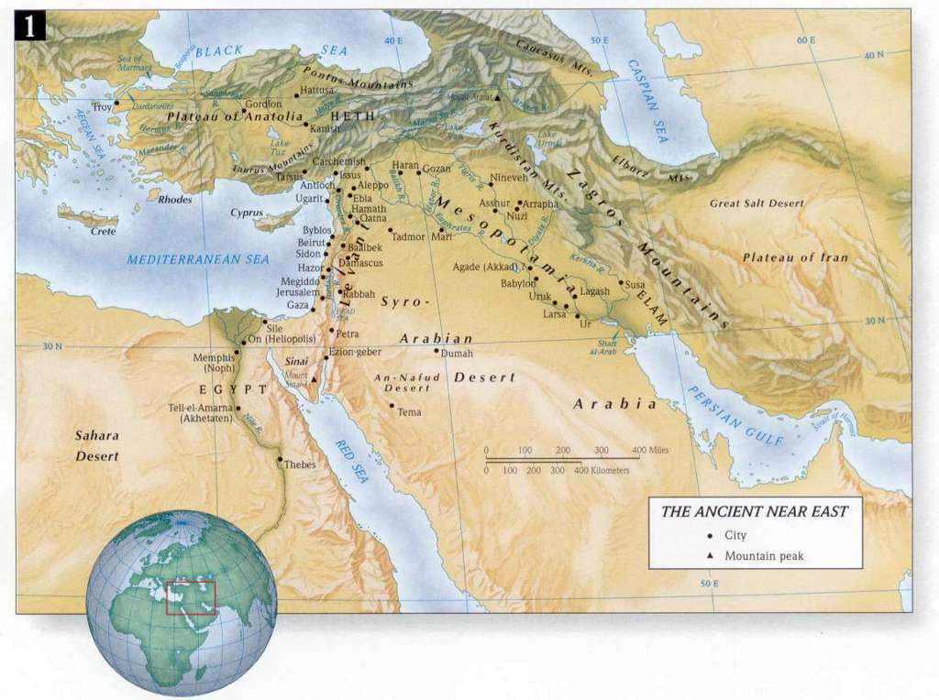

Discussion Questions

1. As you consider Nehemiah’s single-minded zeal for God and the contrasting image of the 3rd soil in Jesus’ Parable of the Sower in Matthew 13, where do you find the weeds (the cares and worries of this world) choking out a fruitful life for God in your own life?
2. How did Sunday’s overview of the Old Testament story add to or change your understanding of the Old Testament?

3. Of the 5 qualities of faithful prayer, which one do you need to be most reminded of at this time and why?

4. Describe a time when God used prayer to significantly shape and change your perspective or move you to action.

5. What is something you feel compelled to pray for regularly at this season in your life? And what specific steps do you hope to take in order to commit yourself to regular and faithful prayer this summer?

